# Exercises: HTML Structure

Problems for exercises and homework for the ["HTML and CSS" course @ SoftUni](https://softuni.bg/courses/web-fundamentals-html5). Submit your solutions in the SoftUni judge system at <https://judge.softuni.bg/Contests/396/HTML-Structure>.

## Simple Navigation Bar

Create a Web Page like the following:

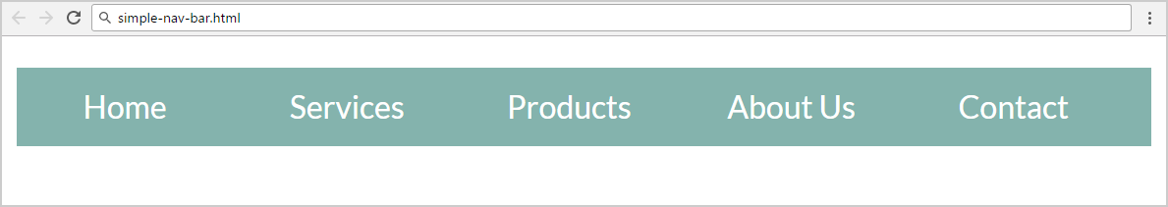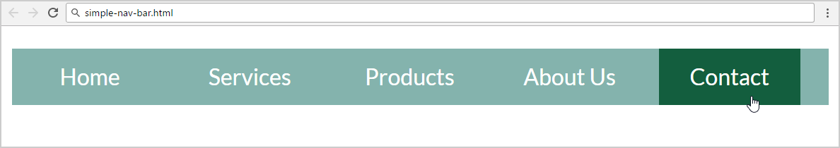

Create two files: "**simple-nav-bar.html**" and "**simple-nav-bar.css**".

### Constraints

* <body>
  + **font-family: "Lato", sans-serif;**
* <nav>tag as container
* Use unordered list in the navigation section
  + Padding: 0;
  + Heigth: 40px;
  + Line Heigth: 30px;
  + Background Color: #84b3ad;
* <li> tag for list item
  + Width: 100px;
  + Margin: 0 5px;
  + Padding: 5px 0;
  + Cursor: **pointer;**
  + Text color: #ffffff;
  + Center the text
* <li>on hover
  + Background Color: #135e3e;
  + Padding: 5px 0;
* Put a **hyperlink** in each list item in the navigation bar.
* Remove the text decoration and fix its color:
  + Put “text-decoration: none;” for the “li a” CSS selector.
  + Change the color for the “li a” CSS selector.

### Hints

* <li> with display:inline-block;in the CSS file
* Put in your CSS all @font-face definitions from <https://fonts.googleapis.com/css?family=Lato:300,400,900>

Your **HTML** file might look like this:

|  |
| --- |
| **simple-nav-bar.html** |
| <!DOCTYPE html> <**html**> <**head**>  <**title**>Simple Navigation Bar</**title**>  <**link rel="stylesheet" href="simple-nav-bar.css"**> </**head**> <**body**>  **<nav>  <ul>**  **<li><a href="#">**Home**</a></li>  *<--TODO: put the rest of list item here -->***  **</ul>  </nav>** **</body> </html>** |

Your **CSS** file might look like this:

|  |
| --- |
| **simple-nav-bar.css** |
| **@font-face** … *(include the code from* [*https://fonts.googleapis.com/css?family=Lato:300,400,900*](https://fonts.googleapis.com/css?family=Lato:300,400,900)*)*  **body** { // TODO }  **ul** { // TODO }  **li** { // TODO }  **li a** { // TODO }  **li:hover** { // TODO } |

## Simple Article

Create a Web Page like the screenshot below.

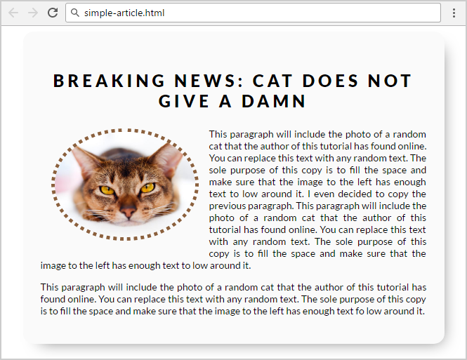

Create two files: "**simple-article.html"** and **"simple-article.css"**

Use **semantic HTML** to create HTML the page.

### Constraints

* <body>
  + font-family:"Lato", sans-serif;[**"https://fonts.googleapis.com/css?family=Lato:300,400,900"**](https://fonts.googleapis.com/css?family=Lato:300,400,900)
* Content => **<article>**
  + Width: 550px;
  + Border radius:15px;
  + Center the content => margin: auto;
  + Padding: 25px;
  + Background color: #fafafa;
  + box-shadow: 10px 11px 35px -14px rgba(0,0,0,0.54);
* <h1> tag for heading
  + Margin bottom: 0;
  + Padding: 10px;
  + Text center
  + Letter spacing: 5px;
* **Image**
  + Width: 200px;
  + Border radius: 50%;
  + Margin: 15px;
  + Border: 5px dotted #8b603d;
  + Use “**left floating**” for the image: <https://css-tricks.com/almanac/properties/f/float/>
* **Paragraphs**
  + Text size: 14px;
  + Use “text-align: justify” to align the text left and right (learn more at <http://www.w3schools.com/css/css_text.asp>).

## Create Header

Create a Web Page like the screenshot below:





Create two files: "**create-header.html**"and"**create-header.css**"

Use **semantic HTML** to create the HTML page.

### Constraints

* <body>
  + Font-family: "Lato", sans-serif;
  + Text color: #ffffff;
* <header>with **class="container"**
  + Center the container
  + Padding: 0 10px;
  + Background:url(background-image.jpg) no-repeat center center;
  + Background size: cover;
  + Height: 800px;
  + Text center
* <h1>for heading
  + Text size: 80px;
  + Padding: 80px 0;
  + Letter spacing: 8px;
  + Transform the heading text to **uppercase** with CSS (see <http://www.w3schools.com/cssref/pr_text_text-transform.asp>).
* Paragraphfor the text
  + Text size: 27px;
  + Font weigth: 100;
  + Margin: 20px;
  + Escape the quotes using &quot;
* <button>with class **btn** for button
  + Text color: #ffffff;
  + Background: none;
  + Border: 5px solid #ffffff;
  + Border radius: 15px;
  + Margin top: 40px;
  + Padding: 15px 45px;
  + Text size: 16px;
* **Button** on hover
  + Background: #000;
  + Border color: #000;
  + Cursor: **pointer;**

### Hints

Reset the CSS margins and paddings, like it is explained here: <https://css-tricks.com/reset-all-margins-padding/>.

## Create Content

Create a Web Page like the following.

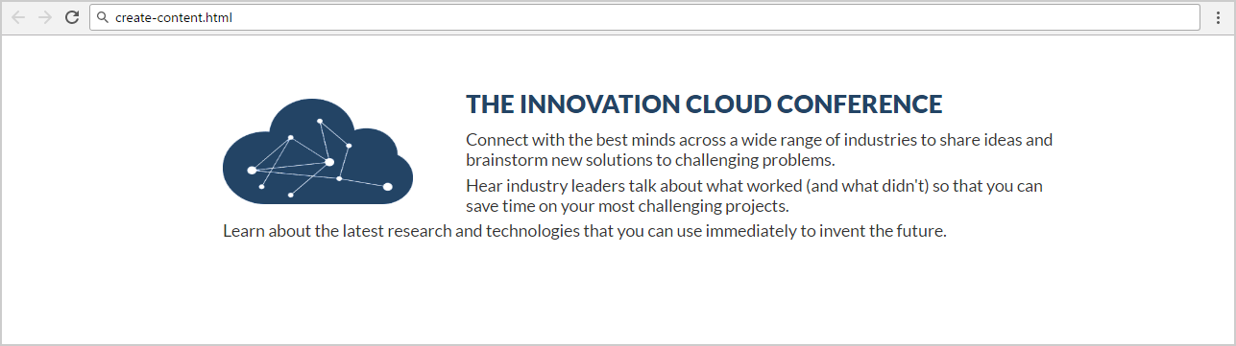

Create two files: "**create-content.html**" and "**create-content.css**"

### Constraints

* Font-family: "Lato", sans-serif;
* <main>as a **container**
  + Margin: 50px 200px;
  + Max width: 1060px;
  + Padding: 0 10px;
* <h2>for heading
  + Text color: #234465;
  + Margin: 10px;
* Paragraph
  + Text size: 16px;
  + Text color: #333333;
  + Margin bottom:5px;
  + Letter spacing: 0;
  + Width:800px;
* Image
  + Align the image on the left side.
  + Width: 180px;
  + Height: 100px;
  + Margin: 10px 50px 0 0;

## Innovation Cloud

Create a Web Page like the following.



Create two files: "**innovation-cloud.html**"and "**innovation-cloud.css**"

Use **Semantic HTML** to create the page

### Constraints

* **Problem 3 + Problem 4**
* **Footer**
  + **Background color: #000000;**
* Text in the footer
  + Text color: **#ffffff;**
  + Text size: **14px;**
  + Height: **80px;**
  + Line height: **80px;**
  + Margin: **0px;**
  + Use the **HTML entity** for the “Copyright” character “**©**”.

## *Conference

Create a Web Page like the following.

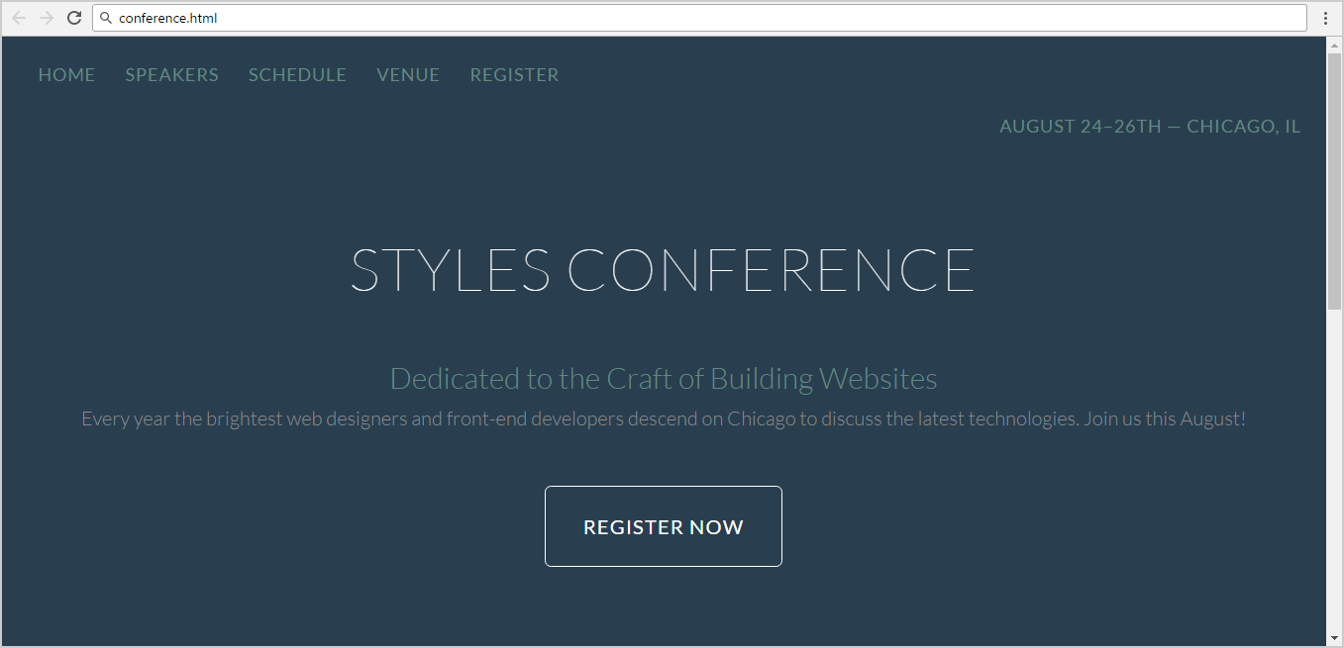

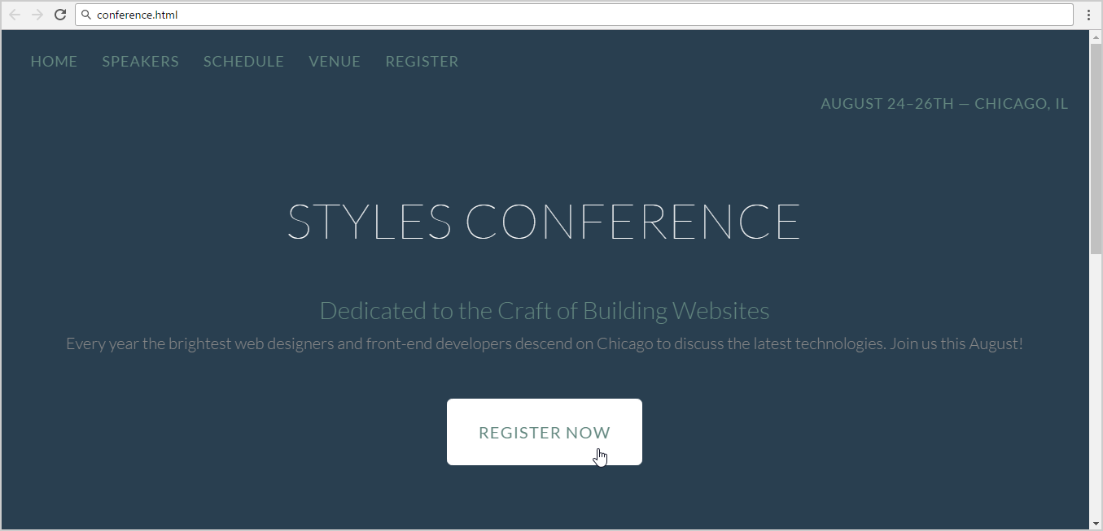

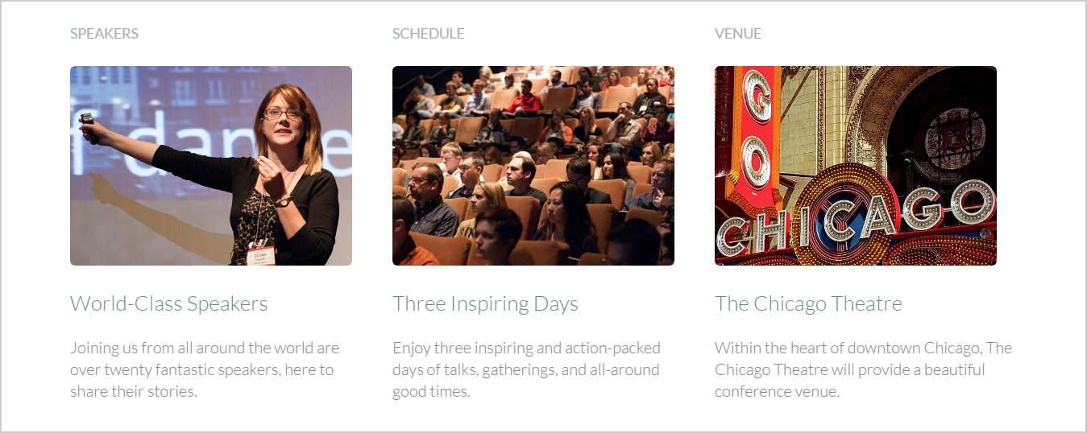



Create two files: "**conference.html**" and "**conference.css**"

Use **semantic HTML** to create the HTML page.

### Hints

* You may use **color picker** software ([search in Google](https://www.google.bg/search?q=color+picker+software)) to select the color of certain screen pixel.
* Use a hyperlink for the **button**.
* Get the “Lato” font from: <http://fonts.googleapis.com/css?family=Lato:100,300,400>.
* Default font: **300 16px/22px "Lato", sans-serif**

## Table

Create a Web Page like the following.

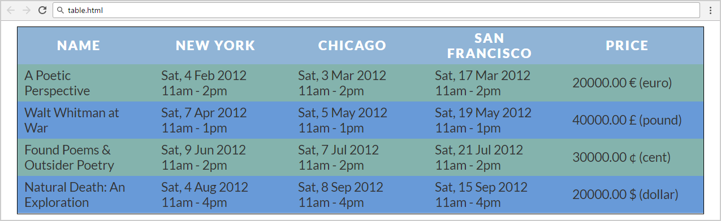

Create two files: "**table.html**" and "**table.css**".

Use **semantic HTML** to create the page.

### Constraints

* Font-family: "Lato", sans-serif;
* Table
  + Text color: #333333;
  + Border spacing: none;
  + Center the **table**
* Table headings
  + Text color: #ffffff;
  + Background color: #90b4d6;
  + Center the text
  + Letter spacing: 2px;
* Table headingfor bold text
  + Padding: 5px 30px 5px 10px;
  + Text size: 18px;
  + Margin: 0;
  + Text align: **left;**
  + Background color: #84b3ad;
* Table data
  + Padding: 5px 30px 5px 10px;
  + Text size: 18px;
  + Margin: 0;
  + Text align **left**
  + Background color: #84b3ad;
  + Width: 150px;

### Hints

Use:

* **tr:nth-child(even) td, tr:nth-child(even) th** { Background color: **#689ad8;**

}

* Search search in Internet for the **HTML entities** representing the currency symbols: <https://www.google.bg/search?q=html+entities+currency+symbols>.

## Book Store

Create a Web Page like the following.

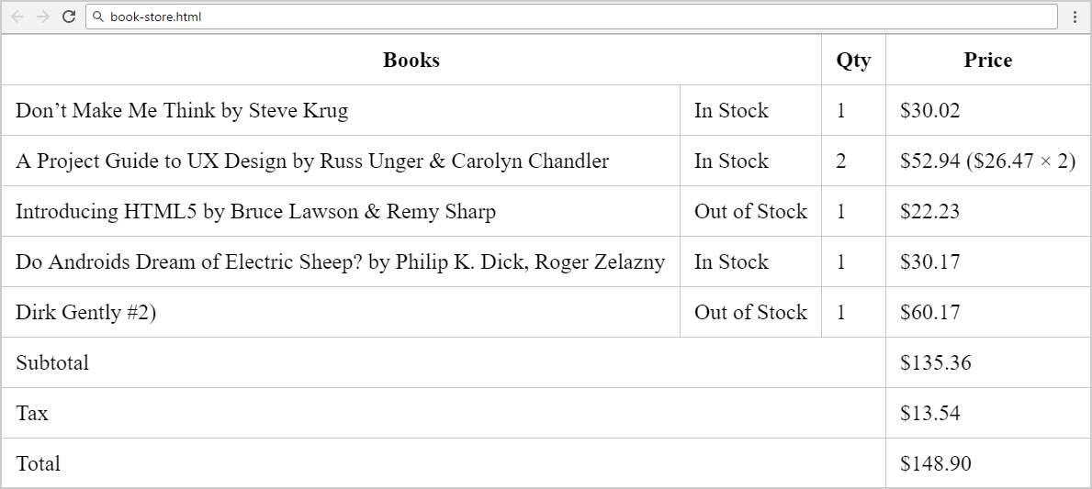

Create two files: "**book-store.html**" and "**book-store.css**".

### Constraints

* **Merge columns** in several table rows by using “colspan”.
* Table border color: #c6c7cc.
* Apply **padding** for all **table cells**.
* **Collapse** table borders to remove the empty space between the cells: <https://css-tricks.com/almanac/properties/b/border-collapse/>.

### Hints

Use:

* First reset the CSS styles.
* Use **&#8217;** for the **apostrophe**.
* Search Internet for **currency symbol HTML entiities** and other special symbols like **&**.